|  |  |
| --- | --- |
| **Name :-** | Aryan Dilipbhai Langhanoja |
| **Enroll No: -** | 92200133030 |

## Seat belt warning system using basic AND & NOT gates

* **Aim** :-

To study the application of a combination of AND and NOT gates in a seat belt warning indicator. The user will be able to construct, simulate and verify the seat belt warning application using the generalized simulator. Display the output on red LED.

* 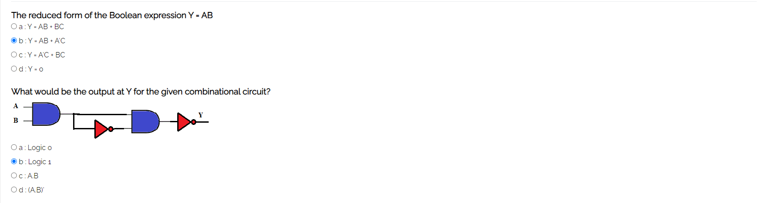**Pre-test :-**

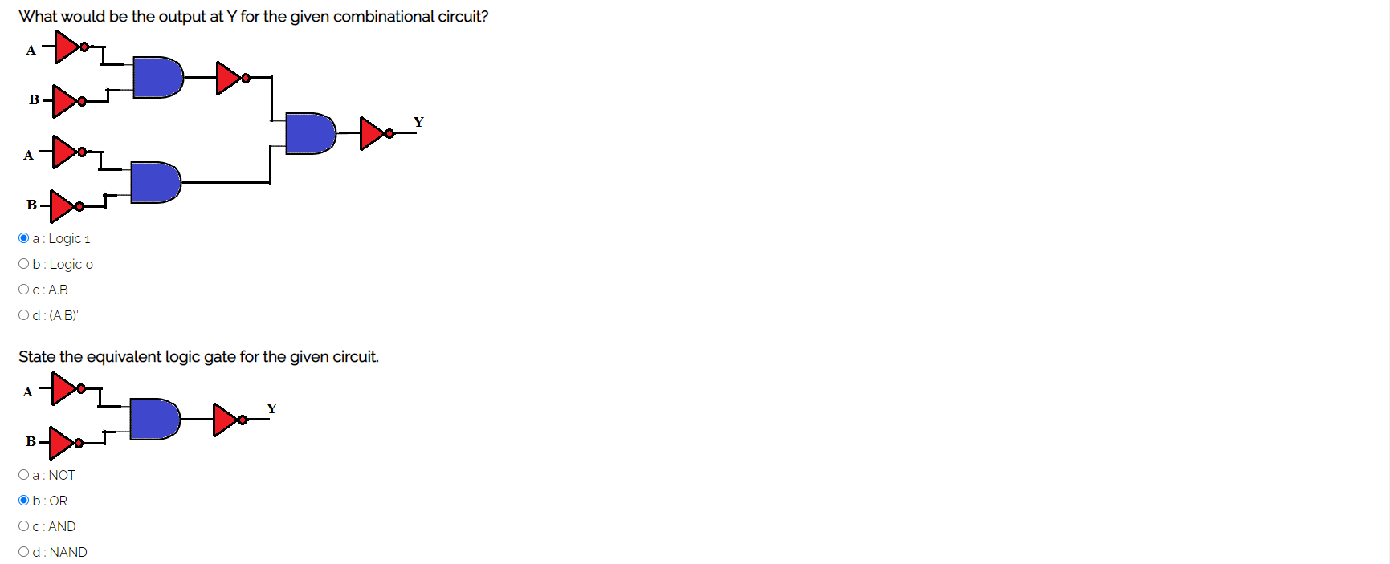

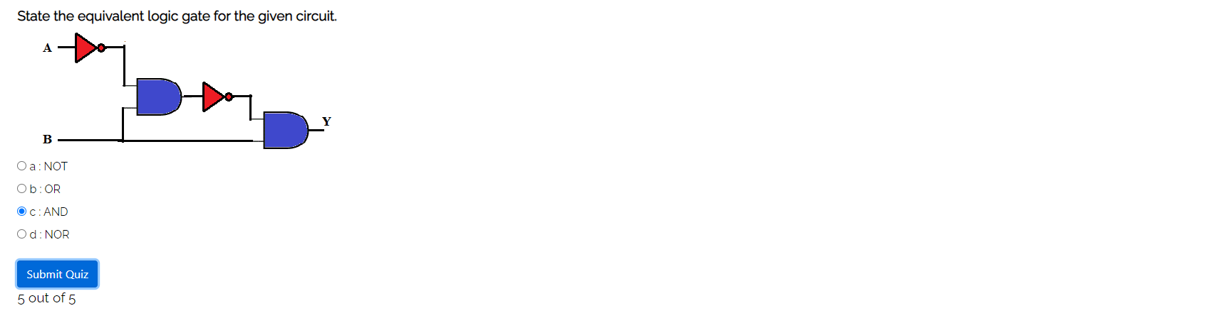

* **Simulation :-**

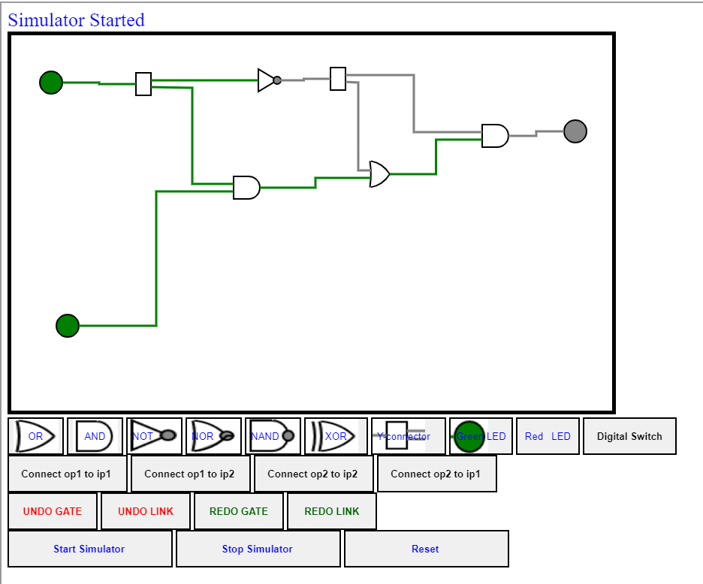

* 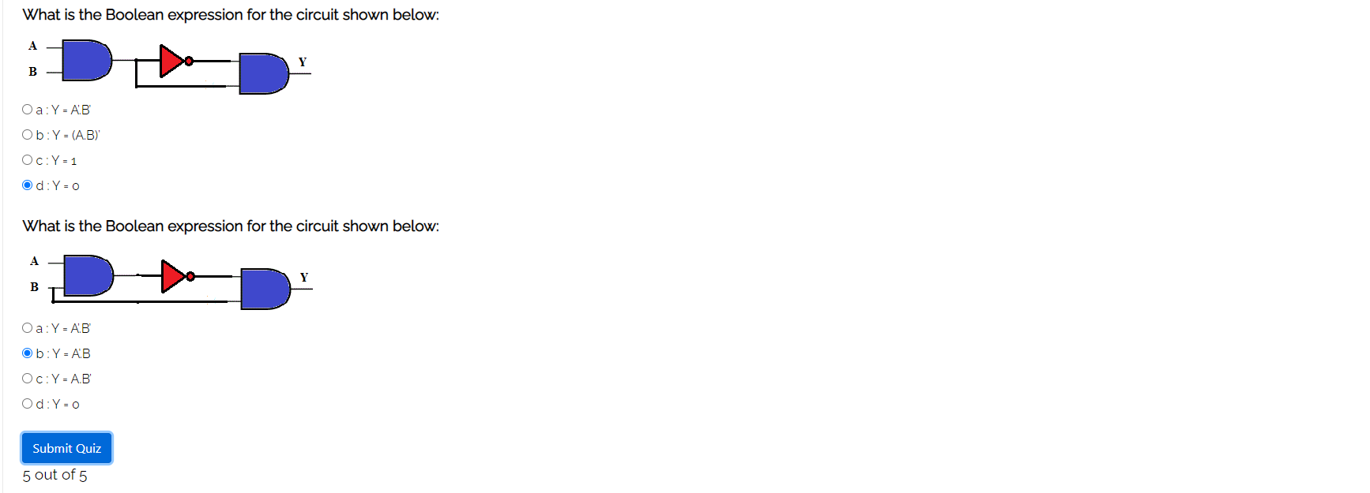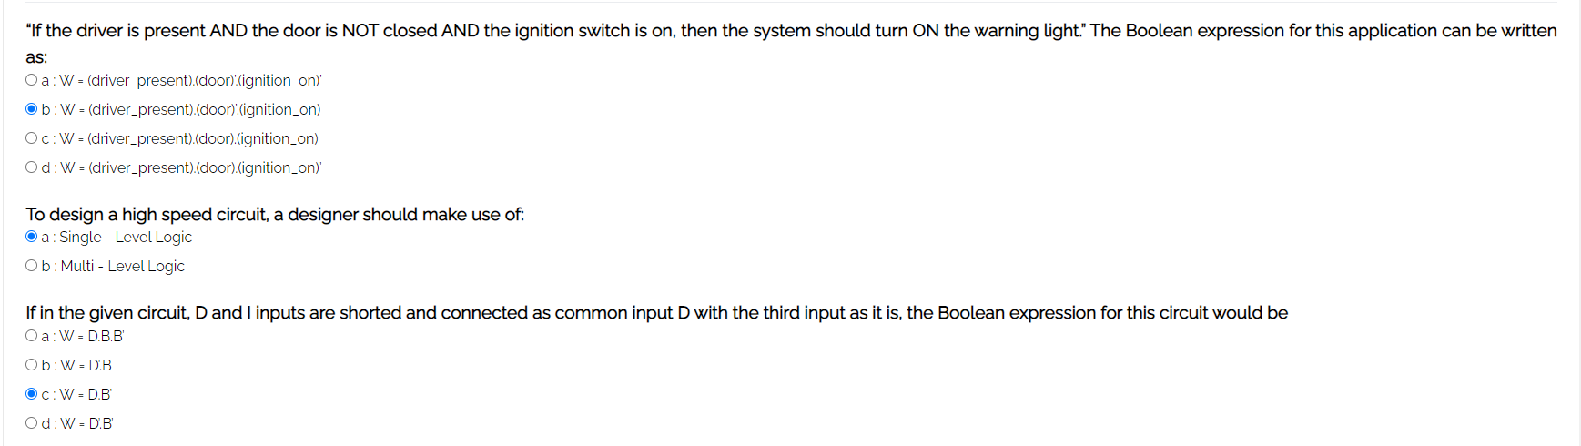**Post-test :-**